**Train And Test The Model Using Classification Algorithms**

Project Name: statistical machine learning TEAM ID: PNT2022TMID40553 approaches to liver disease prediction

There are several Machine learning algorithms to be used depending on the data you are going to process such as images, sound, text, and numerical values. The algorithms that you can choose according to the objective that you might have may be Classification algorithms are Regression algorithms.

Example:

1. Random Forest Classification.

2. Support Vector Machine

3. KNN Classification

You will need to train the datasets to run smoothly and see an incremental improvement in the prediction rate.

Now we apply classification algorithms on our dataset.

Support Vector Machine: Support Vector Machine (SVM) is a supervised machine learning algorithm which can be used for both classification or regression challenges. However, it is mostly used in classification problems. Support Vectors are simply the co-ordinates of individual observation. The goal of a support vector machine is not only to draw hyperplanes and divide data points, but to draw the hyperplane the separates data points with the largest margin, or with the most space between the dividing line and any given data point.

Random Forest Regression: Random forests or random decision forests are an ensemble learning method for classification, regression and other tasks that operate by constructing a multitude of decision trees at training time and outputting the class that is the mode of the classes or mean/average prediction of the individual trees.

K-Nearest Neighbors algorithm: K-Nearest Neighbour is one of the simplest Machine Learning algorithms based on Supervised Learning technique. K-NN algorithm assumes the similarity between the new case/data and available cases and put the new case into the category that is most similar to the available categories.

Build the model

We’re going to use x_train and y_train obtained above in train_test_split section to train our regression model. We’re using the fit method and passing the parameters as shown below.

1. Import the Classification algorithms

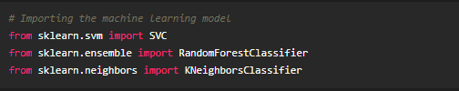

2. Initialize the model

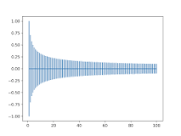

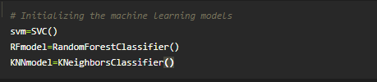

3. Training model with our data.

SVC Model

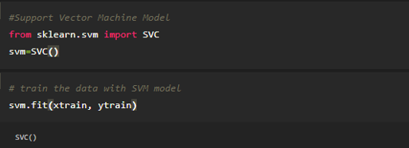

* Random Forest Model

